H.T No
Regulations:
A17

Sreenidhi Institute of Science and Technology
(An Autonomous Institution)
Code No: 6X211 Date: 26-April-2022 (FN)

M.Tech I-Year II-Semester External Examination, April/May - 2022 (Supplementary)
Power System Stability (EPE)

Time: 2 Hours Max.Marks:75

Note: a) No additional answer sheets will be provided.
b) All sub-parts of a question must be answered at one place only, otherwise it will not be valued.
c) Missing data can be assumed suitably.

ANSWER ANY 5 OUT OF 8 QUESTIONS. EACH QUESTION CARRIES 15 MARKS.

Bloom's Cognitive Levels of Learning (BCLL)

Remember | L1 | Apply | L3 | Evaluate | L5
Understand | L2 | Analyze | L4 | Create | L6

 |  |  | BCLL | CO(s) | Marks
1. | a) | Describe the difficulties with reactive power transmission in detail. |  | CO1 | [8M]
 | b) | With the help of neat single line diagrams, explain “Pure angle stability” problem and “Pure voltage stability” problem. |  | CO1 | [7M]
2. | a) | Explain the concept and usage of voltage collapse proximity indicator. |  | CO2 | [8M]
 | b) | Explain how voltage stability is evaluated using Jacobian elements. |  | CO2 | [7M]
3. | a) | From the power utility point of view, state the requirements and features of the “Protection Schemes” necessary to deal with the voltage stability related problems. |  | CO3 | [8M]
 | b) | Explain the steps involved in the mechanism of voltage collapse by which it can be concluded that voltage collapse is a “slow” phenomenon. |  | CO3 | [7M]
4. | a) | Explain the modelling of induction machine for steady state and transient stability studies with the help of equivalent circuit. |  | CO4 | [8M]
 | b) | During voltage decay or voltage swing, voltage at a bulk power delivery high voltage bus drops from 1.05 pu to 0.9 pu. With no regulation, calculate the voltage at the utilization point assuming a reactance of 15% on the load base. (the reactance comprises of 10% bulk power delivery transformer reactance, 3% distribution transformer reactance, and 2% feeder reactance.) the voltage at the load, V is initially 1.0 pu. The 1.0 pu load is a motor with Pv=0 and Qv=2. Capacitive compensation is used to achieve 1.o pu voltage. Calculate the voltage at the load when the source voltage, E, drops to 0.9 pu.  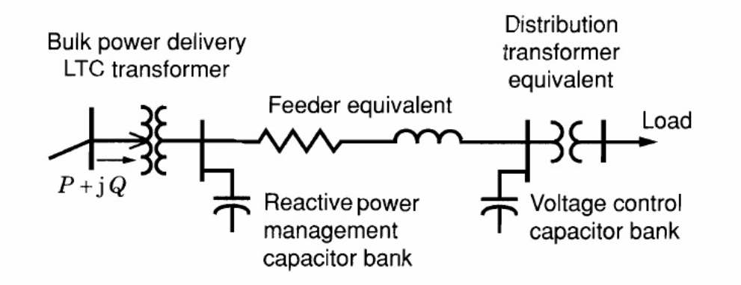 |  | CO4 | [7M]
5. | a) | Describe equal-area criterion for stability in detail and draw a power angle curve to test stability. |  | CO5 | [8M]
 | b) | Using the energy balance criteria, derive an expression for the swing equation of single machine to infinite bus system model to study transient stability behavior of the power system. |  | CO5 | [7M]
6. | a) | What are various discrete supplementary controls used and explain any one control in detail. |  | CO6 | [8M]
 | b) | Explain how the discrete control of excitation systems is implemented. |  | CO6 | [7M]
7. | a) | Explain voltage security with the help of necessary diagram. |  | CO1 | [5M]
 | b) | Discuss briefly about “power modulation of HVDC lines”. |  | CO2 | [5M]
8. | a) | How can voltage stability margin be expressed? Explain. |  | CO4 | [5M]
 | b) | List out and explain ways different to improve voltage stability. |  | CO5 | [5M]

-- 00 -- 00 –

